**Heaven’s Light is Our Guide**

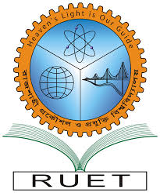

**Rajshahi University of Engineering and Technology**

**Department of Computer Science and Engineering**

**Course No:** CSE.1204

**Course Title:** Sessional based on CSE.1203 (Object Oriented Programming)

**Project No:** 01

**Project On:** Hotel Management System.

**Submitted By** **Submitted To**

Md. Ariful Islam Md. Asifur Rahman

Roll No: 1803046 Lecturer

Section: A Dept. of CSE,RUET

Department: CSE

**Project Details**

This project is on Hotel Management System that will at first show room details of the hotel and take visitors identity as input. Then it will add these in the hotel’s **main resister book** and will also add these in the room’s register book. After that it will confirm the visitors check-in at the hotel.

**# The End #**